Nike Free TR Flyknit 3

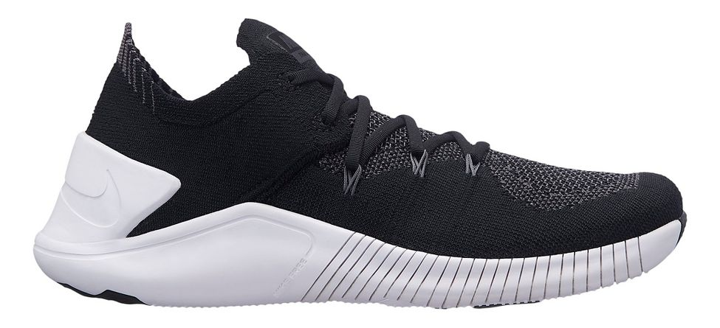

Product code: 1031

The Nike Free TR Flyknit 3 Women's Training Shoe offers lightweight support and breathability for fitness classes. With a wide, flat heel, it also provides exceptional stability during high-intensity training, in the gym and outdoors.

# Nike Free TR8

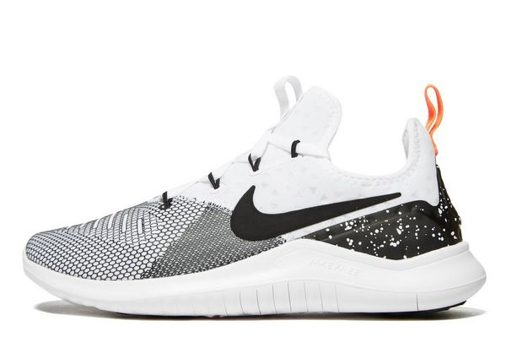

Product code: 1032

The Nike Free TR8 Women's Training shoe has a stronger heel than ever before, plus extra cushioning that hugs and contains your foot. The sole is still unbelievably flexible, offering a natural, lightweight feel and lateral support through every rep.

# Nike Air Zoom Fearless Flyknit Selfie

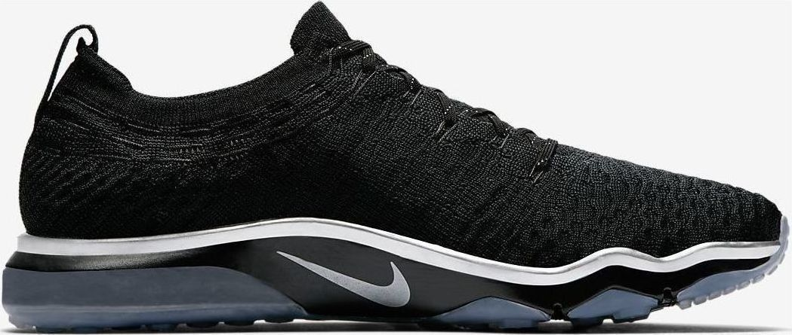

Product code: 1033

The Nike Air Zoom Fearless Flyknit Selfie Women's Training Shoe supports you through quick runs and high-intensity sessions with its flexible stability, responsive cushioning and durable traction.

# Nike Free TR 7 Selfie

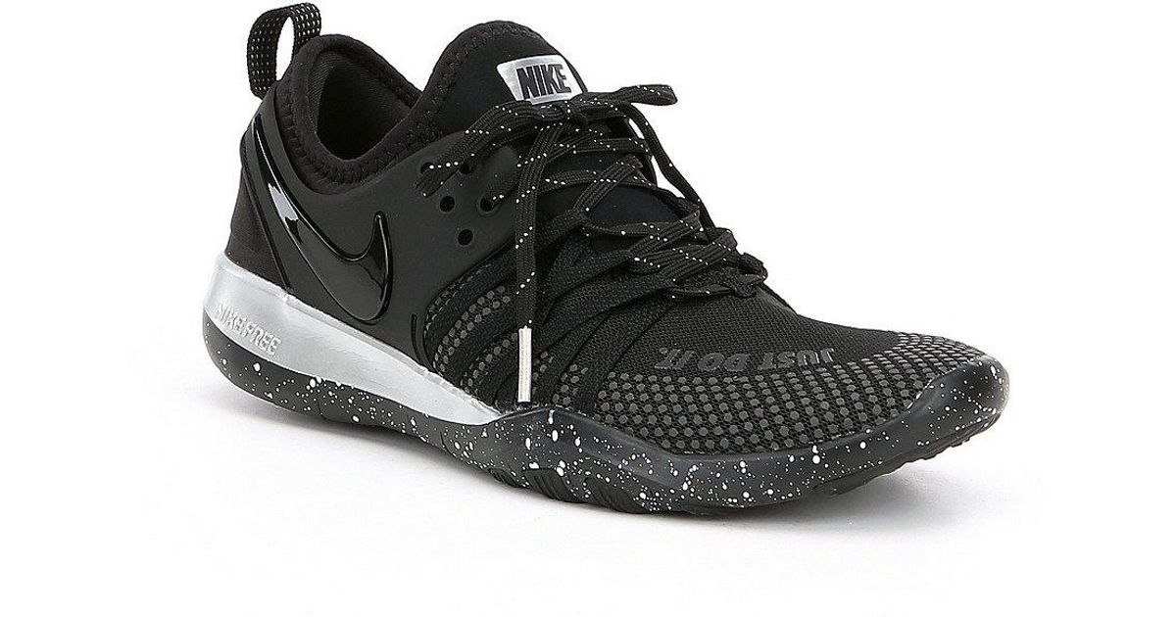

Product code: 1034

Designed for natural movement and lockdown during intense workouts, the Nike Free TR 7 Selfie Women's Training Shoe features a flexible tri-star sole pattern and a lightweight mesh construction.

# Nike Flex Supreme TR 6

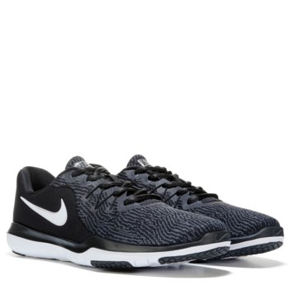

Product code: 1035

The Nike Flex Supreme TR 6 Women's Training Shoe features a flexible construction and sole to promote a natural range of motion during your workout.